
International Journal of Computer Sciences and Engineering Open Access
Research Paper Vol.-6, Issue-9, Sep 2018 E-ISSN: 2347-2693

Smart Hand Glove for Hearing and Speech Impaired

Basil Romi Jose¹, Yogini Lamgaonkar², Raheel Shaikh³, Joshua D’souza⁴, Amey Pednekar⁵, Riyazul Ansari⁶, Varun Prabhu⁷

^{1,2}Assistant Professor, Department of Computer Engineering, Agnel Institute Of Technology and Design, Goa, India
^{3,4,5,6,7} Student ,Department of Computer Engineering, Agnel Institute of Technology and Design, Goa, India

e-mail: bj@aitdgoa.edu.in¹, yl@aitdgoa.edu.in², raheel1551999@gmail.com³, joshuamdsouza98@gmail.com⁴, ameypednakar2705@gmail.com⁵, rriyazul@gmail.com⁶, 16co44@aitdgoa.edu.in⁷

*Corresponding Author: raheel1551999@gmail.com Tel.: +91 9011338788

Available online at: www.ijcseonline.org
Received: ………./2021, Revised: ………..2021, Accepted: ………2021, Published:
Abstract— With the advancement of technology, we can implement a variety of ideas to serve mankind in numerous ways. Inspired by this, we have developed a smart hand glove system which will be able to help the people having hearing and speech disabilities. In the world of sound, for those without it, sign language is a powerful tool to make their voices heard. The American Sign Language (ASL) is the most frequently used sign language in the world, with some differences depending on the nation. We created a wearable wireless gesture decoder module in this project that can transform the basic set of ASL motions into alphabets and sentences. Our project utilizes a glove that houses a series of flex sensors on the metacarpal and inter-phalange joints of the fingers to detect the bending of fingers, through piezoresistive (change in electrical resistance when the semiconductor or metal is subjected to mechanical strain) effect. The glove is attached with an accelerometer as well, that helps to detect the hand movements. Simple classification algorithms from machine learning are then applied to translate the gestures into alphabets or words.
Keywords— Arduino; MPU6050; Flex sensor; Machine learning; SVM classifier

Introduction
India constitutes of 2.4 million people with hearing and speech impairment which holds the world’s 20 percent of the hearing and speech impaired population [1]. These people lack resources which a normal individual should possess. The main reason being the communication gap, as deaf people are unable to hear and dumb people are unable to speak.
It is the natural ability of human beings to see, listen and interact with their external environment. Unfortunately, there are some people who are specially challenged and lack the ability to use their senses to the best extent possible. Hearing and speech impairment is a result of the physical ailment of hearing for deaf people, and speaking for dumb people. On the image processing area, a camera is utilized to take images/videos, which are then processed and picture recognition performed using algorithms that generate words in the display. In visual-based techniques, camera chase methods are widely utilized. When a speech impaired person tries to communicate with a person who does not understand sign language, the normal individual finds it challenging to comprehend what the deaf and dumb person is trying to convey and ask him/her to show gestures for the same. Thus, these people have a language of their own to communicate with us. The only problem is to understand this language.
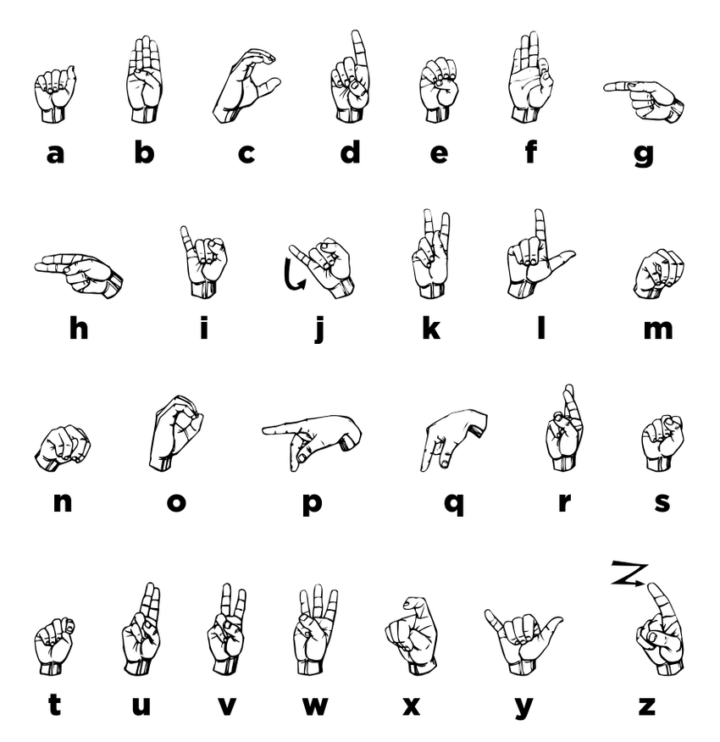

Fig. 1 American Sign Language

The primary goal of the suggested project concept is to develop a low-cost gadget that will allow the deaf and hard of hearing to communicate with others using the Smart Hand Glove. It implies that using Smart Hand Glove by the deaf person enables them to communicate productively with a normal person which in turn bridges the gap between them. Challenges faced by the deaf person with respect to their employment can be overcome by this method. So, in the proposed project, an intelligent microcontroller-based system using Flex sensors will be developed which will be able to recognize the hand gesture using a classification algorithm.

Literature Review

Survey

According to the analysis done, one out of every five people is deaf or dumb on this planet is an Indian. In India about more than 1.5 million deaf people utilize Sign Language as a method of correspondence [2]. Normal parents of deaf children or vice versa use gesture-based communication. However, because of these issues, an automated Sign-to-Speech/text language interpretation system might help the hearing challenged access more information. It may also be used as a teaching tool to familiarize yourself with any type of gesture communication. Plato's Cratylus [2], written in the 5th century BC, is one of the oldest examples of gesture-based communication. Juan Pablo Bonet published Reduction of letters and art for teaching mute people to communicate in 1620, which is regarded as the first modern research of communication by vocal gestures, laying out a plan for voice training for hard of hearing people and a standard letter set.

Hand gesture recongnition techniques

Hand gesture recognition can be accomplished using two main types of sensors namely contact sensors and non-contact sensors [3].

Non-contact approach

On the image processing area, a camera is utilized to take images/videos, which are then processed and picture recognition performed using algorithms that generate words in the display. In visual-based techniques, camera chase methods are widely utilized. The user generally wears a glove with specific colours or markings to indicate certain areas of the hands, particularly the fingers. As the user performs a sign, the cameras record continuously changing images of the hand, which are subsequently processed to recover the hand shape, position, and orientation. The need of sophisticated algorithms for data processing is a disadvantage of vision-based methods. Another challenge in image and video recognition requires different lighting conditions, backgrounds and field of view constraints and occlusion (often occurs when multiple objects come very close and seemingly merge or combine with each other).

Contact approach

To overcome the drawbacks of the non-contact approach and accurately recognize gestures, we can make use of sensors for gesture recognition based on the strain gauges to sense deformations. These bends are changed to electric signals. By measuring the electric signals, the sensor array can estimate the degree of deformations, along with compression and tension caused by the bend angle of the fingers.
A bend sensor comprises of three components: a flexible tube, an infrared sensitive (photo diode) and an infrared diode. Seven bend sensors will be used to map the bending of the fingers from which 4 are placed on the proximal interphalangeal joints (PIJ) and 3 are placed in between the metacarpophalangeal joints (MCP). The sensors bend with the curve of the joints on which they are placed. The intensity of light plummeting on the photo diode and hence the current through the same decreases as the pipe bends due to the bending of the fingers while making a gesture [4].
The Hall Effect sensor (MH183) is easily available. When the South Pole is placed in front facing the Hall sensor, it generates a 0.1-0.4V output. Hall Effect sensors are mounted on the finger tips and the magnet is mounted on the palm in such a way that the South Pole faces the ceiling. Now if we bend our fingers to touch our palms, these Hall Effect sensors come in close range to the magnet and the inbuilt Schmitt triggers a low signal. The output is high when fingers are not within close proximity of the palm (magnets).

Contribution of Machine learning toward the disable community

We live in a world where not everyone is blessed with inherent abilities that most of the human race possesses, when observed carefully one can notice that there are many who are suffering from some kind of a disability. People with these types of disabilities are usually termed as ‘Special’ and are usually grouped separately in our society due to their failure in functioning properly in a normal society. This creates sense of divide and a sort of discrimination among the people which shouldn’t be there at the first place, but the advent of modern science has bridged the gap between an average person and a person with any type of disability. One such technology that can contribute in closing this gap is Artificial Intelligence (AI) which uses branches like Machine Learning and Deep Learning and can help people with Sight, Hearing and Speech disabilities. [5]

block diagram
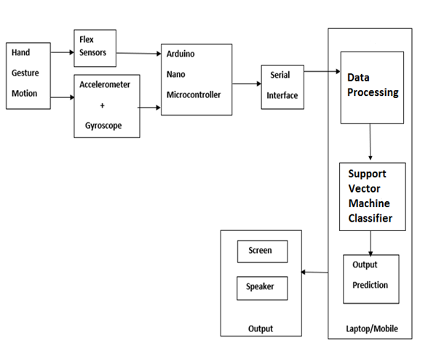

Fig. 2 Block diagram of Proposed System

As seen in figure 4.2, the hand gesture is recorded making use of the flex sensor and the accelerometer. This sensor data is transmitted to the Arduino microcontroller which converts the analog signal to digital signal. This data is then passed to the data processing unit via the serial interface. The data processing unit normalizes and standardizes the data which is then given to the SVM classifier. The SVM classifier makes the prediction and the output is displayed on the computer screen.

Arduino nano microcontroller
The Arduino Nano is breadboard friendly microcontroller which is smaller in size compared to other Arduino boards. It is based on the ATmega328. Functionality of Arduino nano is shown to be similar with the Arduino Duemilanove, but the package is different. The nano boards do not aid a DC power jack. It uses a Mini-B USB cable to power and program the microcontroller. It has 8 analog input pins and 14 digital pins. The analog pins supports 10 bits of resolution which provides 1024 different values and each of the digital pins could be used as an input or output. The upper end of the range can be commuted using the analogReference() function, by default it is 5 volts. Serial pins RX and TX which are at port 0 and 1, are used to receive and transmit serial data via a serial connection. Out of the 8 analog pins, 6 and 7 cannot be used as digital pins. In addition to this, some of the pins (I2C: A4 (SDA) and A5 (SCL)) experience specialized functionality. It also assists I2C (TWI) communication using the Wire library. It can be easily programmed the Arduino IDE using the hardware programming language called processing, which share similarities with C language.
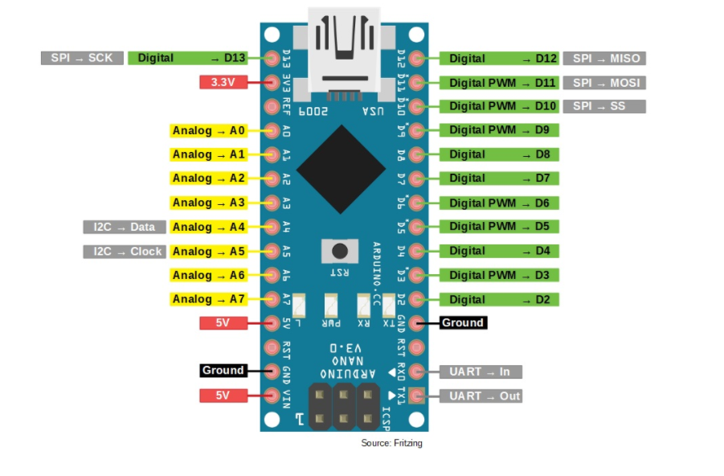
Fig. 3 Arduino nano pin layout

Interfacing of Flex sensors with Arduino nano

Arduino consists of analog pin which is wired to the converter known as analog-to-digital converter (ADC or A/D). This converter converts analog voltage values to digital values for easier use and application. In Arduino, it’s a 10-bit converter which mean, the conversion value is between 0 to 1023.
The Arduino will read a value of 1023 at a high of 5V (maximum) and read a value of 0 for a low of 0 volts (minimum).

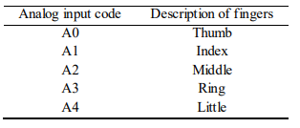

Fig. 4 Connection of flex sensors with Arduino nano

The output voltage you measure is the voltage drop against the pull-down resistor, not across the flex sensor. The output of the voltage divider configuration is described by the equation:
Vo=VCC*(Rflex/ (Rflex +R))Eq 1: [6]
The output voltage will vary depending upon the bend radius.
For example, at a 5V supply and 47K pull-down resistor and a (0⁰) bend angle, the resistance is comparatively low (around 25kO). Thus, the following output voltage:
V0=5V*(25KΩ/(25KΩ+47Ω)) =1.74V
When flexed at an angle of 90°, the resistance rises to about 100KΩ. This results in the following output voltage:
V0=5V*(100KΩ/(100KΩ+47Ω) =3.4V

Interfacing of MPU6050

MPU6050 sensor module is complete 6-axis Motion Detecting Device. It combines the functionality of 3-axis Gyroscope, 3-axis Accelerometer, and a Digital Motion Processor. It communicates with the micro controller via I2C bus interface. Rotational velocity of the object along the X, Y, Z axes is detected using the MPU6050. The angular velocity along each axis is measured in degree per second unit. The sensor data of MPU6050 module is comprised of 16-bit raw data which is represented in 2’s complement form. The VCC of the sensor module is connected to 5V power supply and GND pins GND power pin on the Arduino board with the connecting wires. To establish the I2C serial bus communication, the SDA and SCL pins of the sensor module is connected to the A4 and A5 pins of the microcontroller respectively.

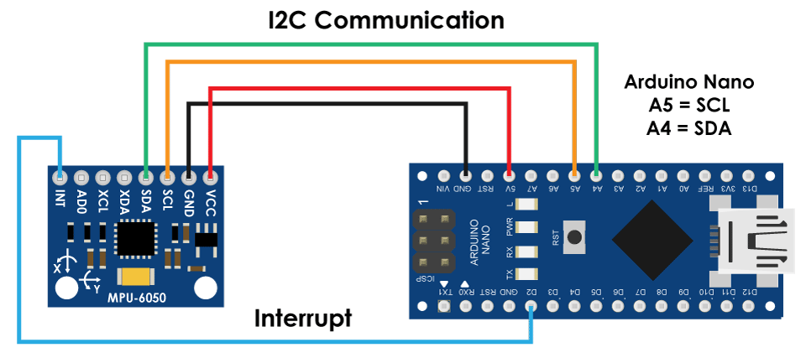

Fig. 4 Connections between MPU6050 and Arduino

IMPLEMENTATION

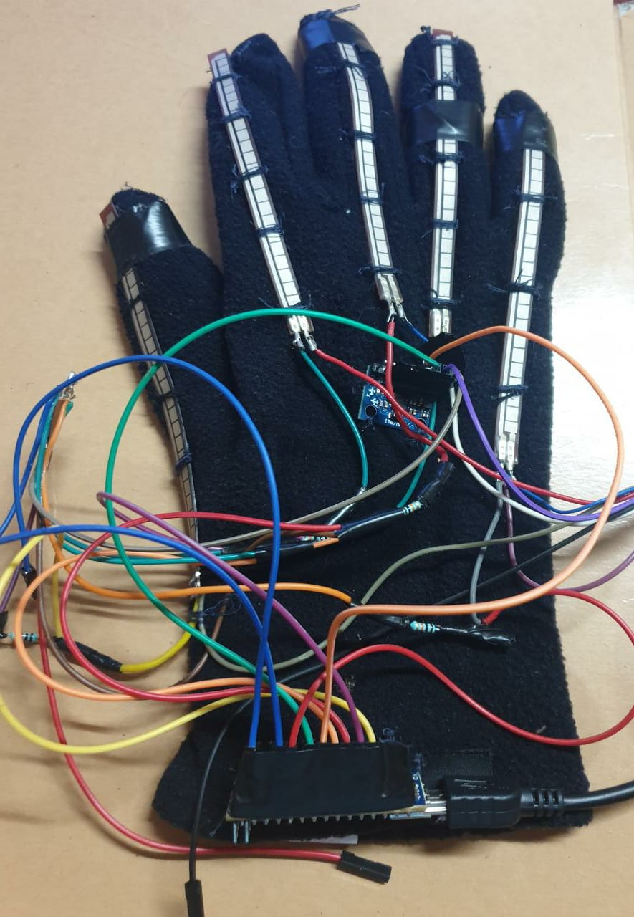

Fig. 5 Glove prototype

The gloves prototype is shown in Fig. 5. The flex sensors are attached to each finger along with a 10 KΩ resistor thus creating a voltage divider circuit, the MPU6050 is mounted on the back of the palm of the hand of the glove along with Arduino nano making it a breadboard independent setup.

The glove operates in the following manner:
- Capturing bend angles & spatial orientation
- Processing Data
- Executing machine learning
- Displaying on GUI

Capturing bend angles & spatial orientation

The flex sensors along with 10 KΩ resistor attached to the glove help in capturing the bend angle based on the resistance produced in the flex sensors. The 10 KΩ resistor forming a voltage divider avoids producing garbage values. The MPU6050 mounted on the palm provides the X, Y, Z coordinates in the spatial domain. The data from the glove is converted from analog to digital using the arduino nano microcontroller. This captured data is sent to the computer for further processing via the serial port using a USB data cable.

Processing Data

The received data from the microcontroller to the computer is converted to a suitable form for the machine learning task, in which we normalize the data. This is done to in order to standardize the flex sensor and MPU6050 readings. This normalized data is sampled and linearized using linear interpolation. This makes the data discrete and suitable for machine learning algorithm.

Executing machine learning

The machine learning process consists of three parts that is
- training phase
- learning phase
- testing phase

Training phase

In this phase a data set is created by recording the continuous data for each gesture. This can be easily done by writing a simple python code. The continuous data is stored in the form of a .CSV (comma separated values), for each gesture a sample size of 100 records were recorded, the size of the sample can vary depending on one’s application. This created file is then used for further processing.

Learning phase

The .CSV file from the above phase is converted to a data fame which is use by the SVM algorithm this is done so that we do not work directly on the original data set. In order to perform classification, the data set has to be split into training and testing data sets in the ratio of 8:2 respectively. The SVM classifier used the RBF kernel along with the parameter’s gamma 0.01 and C in the range of 0.00000000001 to 100000000. The confusion matrix is show in the figure below.

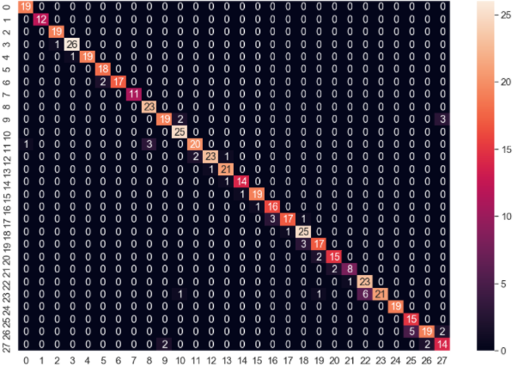

Fig. 6 Confusion matrix

Testing phase

The SVM model is tested with the test data set and accuracy of 91% is achieved using the parameters of C=7 and gamma =0.01. The gestures are classified in real time with a delay of 3 seconds between each consecutive gesture.

Displaying on GUI

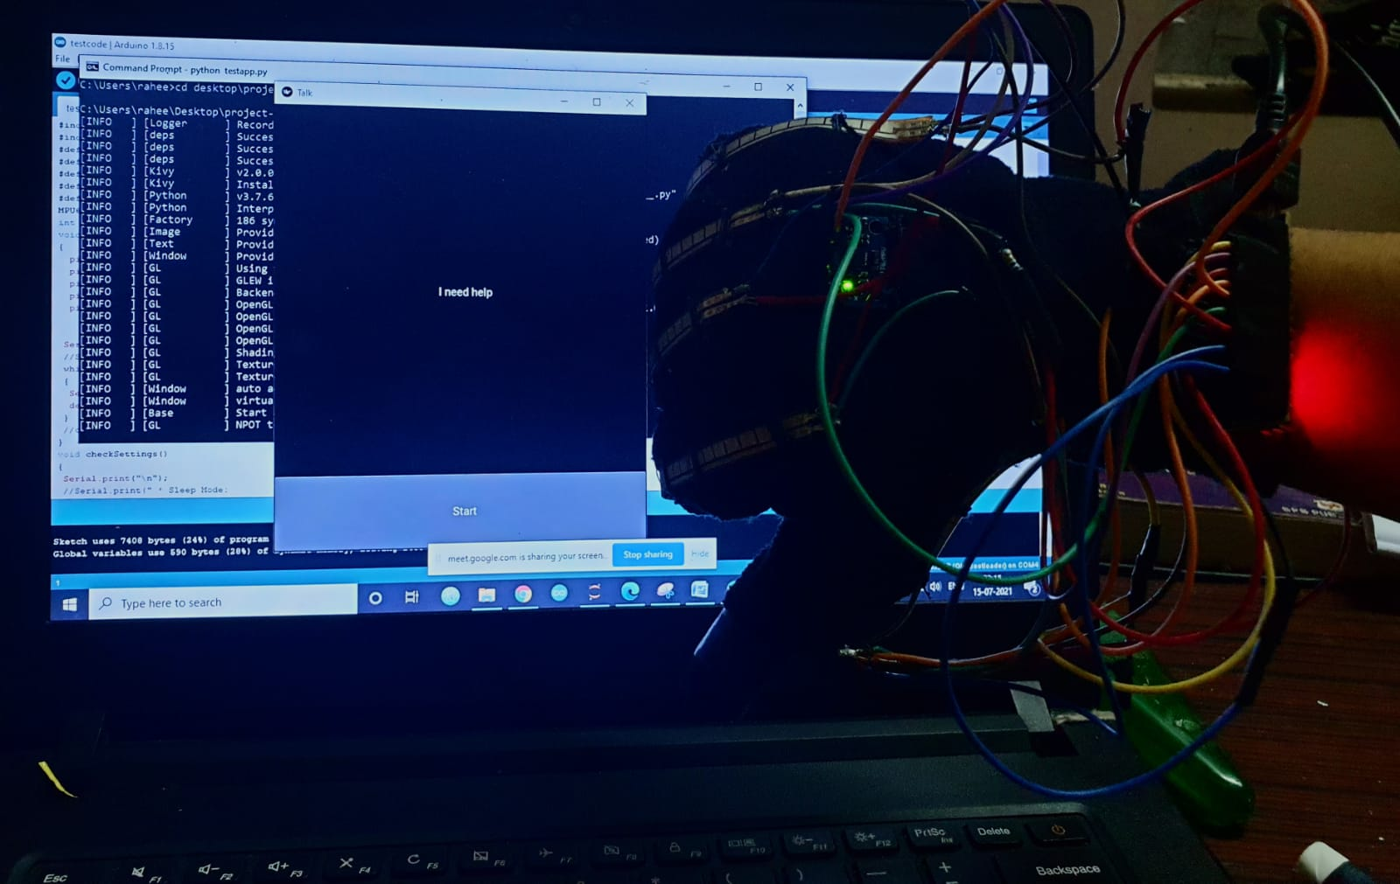

Fig. 7 Testing of prototype
The resulting classified ASL gesture is displayed on the GUI shown in the Fig.7 & 8.

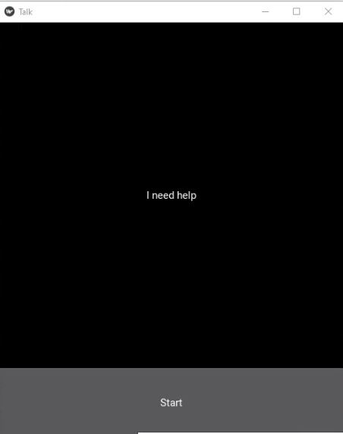

Fig. 8 Graphical user interface

CONCLUSION

In this paper, smart hand glove is designed using flex sensor, MPU6050 and Arduino nano microcontroller with which hand gestures are classified correctly with the help of the SVM classifier for which the data set was split in 8:2 ratio that is 80% training data and 20% testing data. The SVM classifier used the RBF kernel with parameters C=7 and gamma=0.1 and produced an accuracy of 91%. We have further widened the scope of the project by adding additional hand gestures for basic commands example “I am good” and “I need help” where thumbs up and thumbs down represents the gestures respectively.
This prototype represents only single-handed gesture recognition, whereas ASL and some other sign languages may require both the hands for communication. Another glove can be replicated in order to solve this problem. So, in the future both the glove can be designed with better accuracy using high quality sensors. This prototype is comparatively less expensive than other prototypes that involve visual based gesture recognition system.

Acknowledgment

We are greatly indebted to our guide Prof. Basil Jose, Faculty, Computer Engineering Department, Agnel Institute of Technology and Design, Goa for his valuable guidance throughout the dissertation, without which the study undertaken would not have been accomplished at all. Our sincere thanks to our co-guide, Yogini Lamgaonkar, Faculty, Department of Computer Engineering, Agnel Institute of Technology and Design, Goa for the constant support and encouragement rendered throughout the mission.

Our sincere thanks to our Head of Department Prof. Snehal Bhogan for the constant support and encouragement rendered throughout the project.

References

[1] Varshney, Saurabh. "Deafness in india." Indian journal of otology 22.2 (2016): 73.

[2]“Smart Glove for Hearing-Impaired.” International Journal of Innovative Technology and Exploring Engineering, vol. 8, no. 6S4, 2019, pp. 1188–1192., doi:10.35940/ijitee.f1245.0486s419.

[3] Byun, Sung-Woo, and Seok-Pil Lee. "Implementation of hand gesture recognition device applicable to smart watch based on flexible epidermal tactile sensor array." Micromachines 10.10 (2019): 692.

[4] Chouhan, Tushar, et al. "Smart glove with gesture recognition ability for the hearing and speech impaired." 2014 IEEE Global Humanitarian Technology Conference-South Asia Satellite (GHTC-SAS). IEEE, 2014.

[5]Chaudhary, Suyash. “How Machine Learning Can Contribute to the Disabled Community.” Medium, Medium, 30 July 2019, medium.com/@suyash15122/how-machine-learning-can-contribute-to-the-disabled-community-5b83e7847183.

[6]“How to Use an Arduino Gyroscope Sensor.” OZEKI, www.ozeki.hu/p_2987-how-to-use-a-gyroscope-sensor-in-arduino.html.

Authors Profile
Mr. Basil Romi Jose has completed his Bachelors of Engineering in Information Technology & Masters of Engineering in Computer Science & Engineering from Goa College of Engineering Goa. Currently an Assistant Professot at Agnel Instittue of Technology & Design, Assagao, Goa in the Computer Engineering Department.
Ms. Yogini Lamgaokar has pursued her B.E. in Agnel Institute of Technology & Design, Assagao, Bardez Goa in the year 2018. She has Completed M.E. in Computer Science and Engineering from Goa College of Engineering Farmagudi, Ponda Goa in the year 2020.
Mr. Raheel Shaikh, BE Students, Dept. of Computer Engineering, Agnel Institute of Technology and Design.
Mr Joshua Dsouza, BE Students, Dept. of Computer Engineering, Agnel Institute of Technology and Design.
Ms Amey Pednekar, BE Students, Dept. of Computer Engineering, Agnel Institute of Technology and Design
Ms Riyazul Ansari, BE Students, Dept. of Computer Engineering, Agnel Institute of Technology and Design.
Mr Varun Prabhu, BE Students, Dept. of Computer Engineering, Agnel Institute of Technology and Design.

